**Energy calculation of Quantum Mechanical model of Caffeine Molecule using Gamess Software**

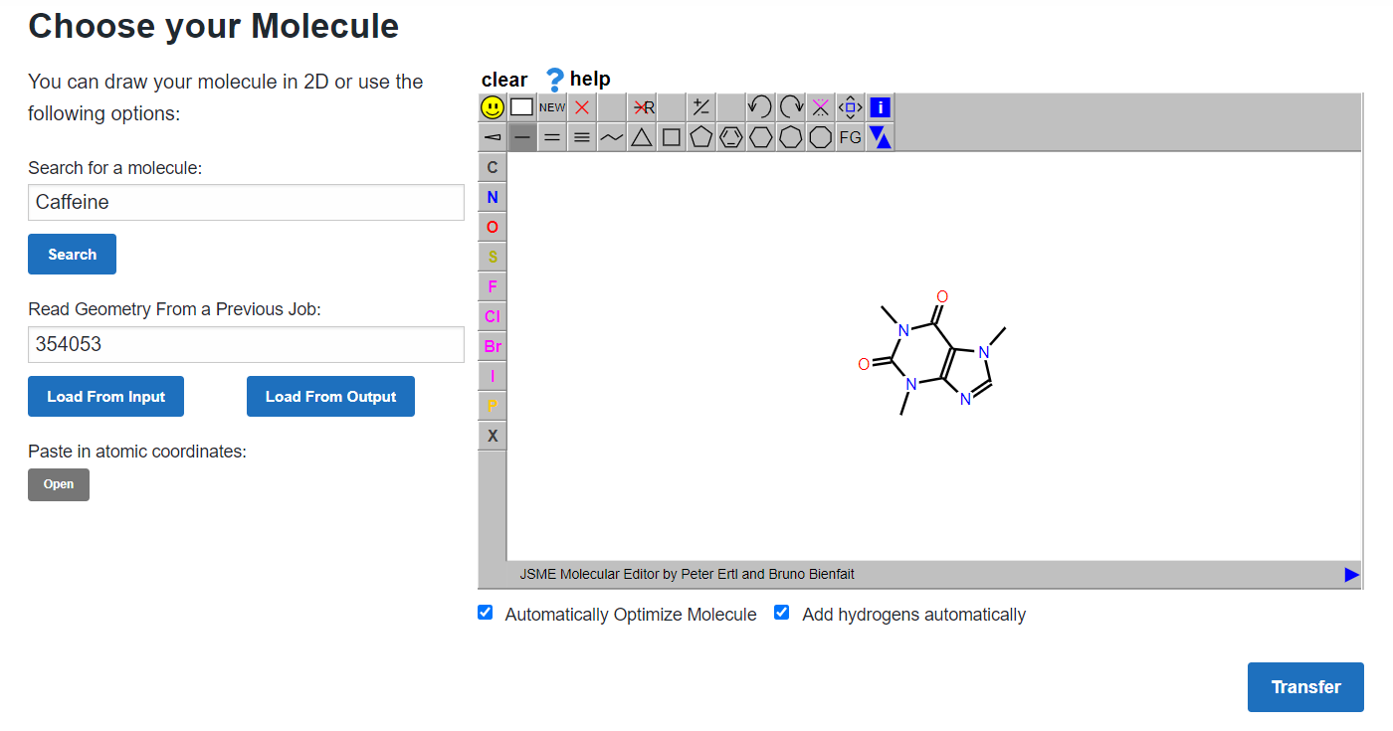

Optimized Structure:

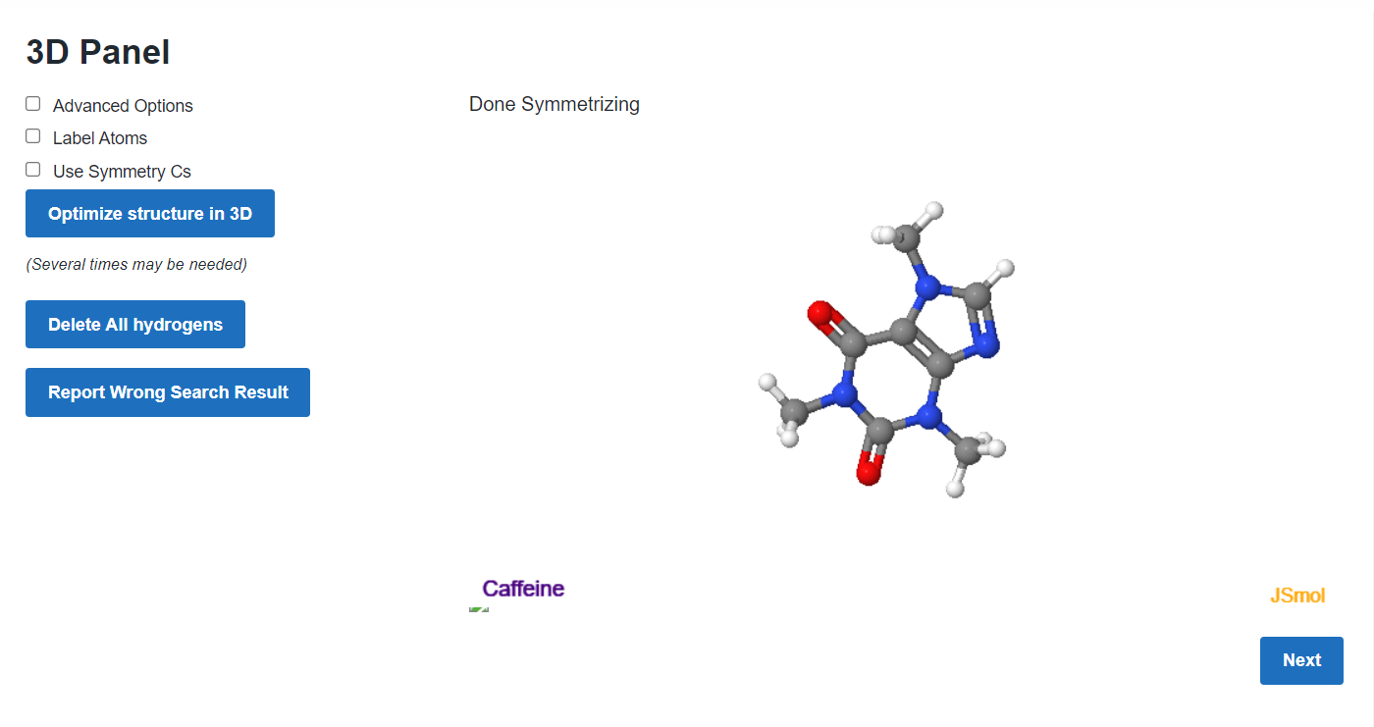

Energies of various Basis set:

i) AM1:

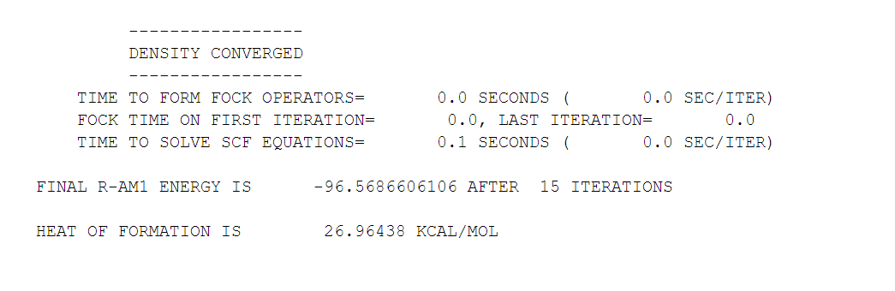

ii) PM3:

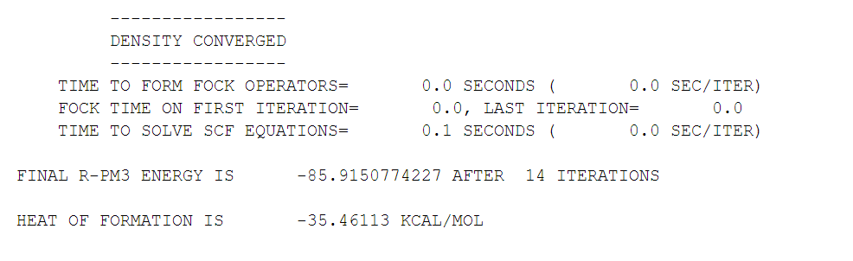

iii) PM6:

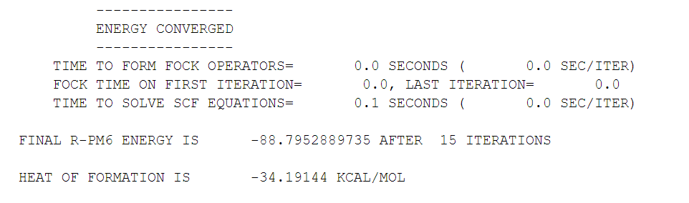

iv) STO-3G:

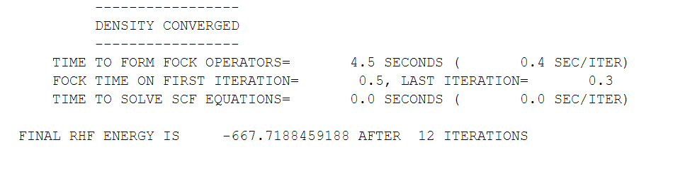

v) 3-21G:

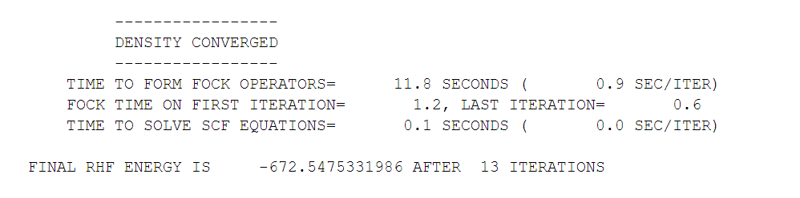

vi) 6-31G*:

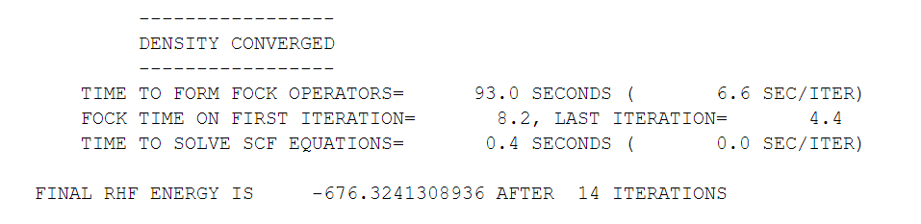

vii) 6-311G**:

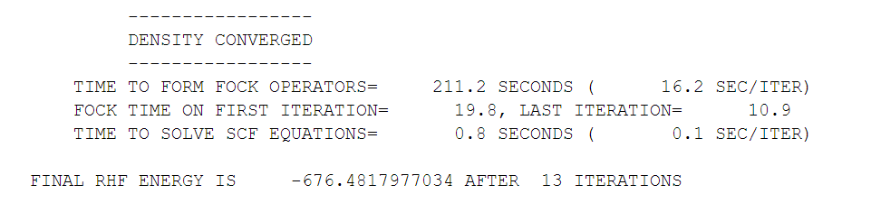

viii) 6-311G**+:

